FERTILIZERS-RECOMMENDATION-SYSTEM-FOR-DISEASE-PREDICTION

NALAIYA THIRAN IBM PROJECT REPORT

TEAM ID: PNT2022TMID08085

Submitted By:

AC19UEC042 –BUVIYA.V

AC19UEC009-AMARAVATHI. U

AC19UEC015-BABY. L

AC19UEC042- EBENEZER PAULIN. S

in partial fulfillment for the award of the degree

of

BACHEOR OF ENGINEERING

In

Department Of Electronics and communication

Engineering,

Adhiyamaan college of engineering

Hosur

CONTENT

1. INTRODUCTION

1.1.Project overview

1.2.Purpose

2. LITERATURE SURVEY

2.1.Existing problem

2.2.Problem statement

3. IDEATION PHASE

3.1.Brainstorm & idea prioritization

3.2.Empathy Map

4. REQUIREMENT ANALYTICS

4.1.Functional requirement

4.2.Non-Functional requirement

5.PROJECT DESIGN

5.1 Data Flow Diagrams

5.2 Solution & Technical Architecture

5.3 User Stories

6. PROJECT PLAINING

6.1.Sprint Planning & Estimation

6.2.Sprint Delivery Schedule

7. CODING & SOLUTIONING

8. TESTING

8.1.Test Cases

8.2.User Acceptance Testing

9. RESULTS

9.1.Performance Metrics

10. ADVANTAGES

11. DISADVANTAGES

12. CONCLUSION

13. FUTURE SCOPE

14. APPENDIX

1.INTRODUCTION:

Agriculture is the most important sector in today’s life. Most plants are affected by a wide variety of bacterial and fungal diseases. Diseases on plants placed a major constraint on the production and a major threat to food security. Hence, early and accurate identification of plant diseases is essential to ensure high quantity and best quality. In recent years, the number of diseases on plants and the degree of harm caused has increased due to the variation in pathogen varieties, changes in cultivation methods, and inadequate plant protection techniques.

An automated system is introduced to identify different diseases on plants by checking the symptoms shown on the leaves of the plant. Deep learning techniques are used to identify the diseases and suggest the precautions that can be taken for those diseases.

1.1.Project Overview

Plant disease prediction helps in the detection and recognition of the plant diseases. The images of plants are captured and analyzed for certain symptoms using Computer vision and image processing. By identifying the disease, the deficit nutrients that lead to the disease are found. Based on the available data on fertilizers, the necessary nutrient rich fertilizers are recommended.

1.2.Purpose

The plant diseases may lead to abnormal functionalities which may end up with the death of the plant. The project aims at recognizing the symptoms at the early stages. The project also aims at guiding the farmers with the proper choice of the fertilizers that are required to counter the deficiency of the nutrients that cause the disease.

2.Literature Survey

2.1.Existing Problem

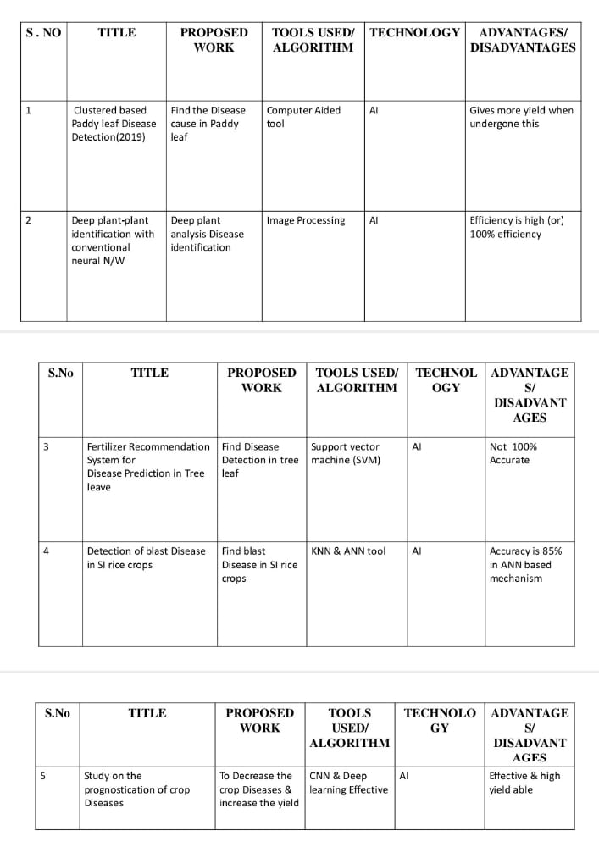

2.2) References

[1] Semi-automatic leaf disease detection and classification system for soybean culture IET Image Processing, 2018

[2] Cloud Based Automated Irrigation And Plant Leaf Disease Detection System Using An Android Application. International Conference on Electronics, Communication and Aerospace Technology, ICECA 2017.

[3] Ms. Kiran R. Gavhale, Ujwalla Gawande, Plant Leaves Disease detection using Image Processing Techniques, January 2014. https://www.researchgate.net/profile/UjwallaGawande/publication/31 4436486_An_Overview_of_the _Research_on_Plant_Leaves_Disease_detection_using_Image_Proce ssing_Techniques/links/5d37106 64585153e591a3d20/An-Overview of-the-ResearchonPlant-Leaves-Diseae detection-using-ImageProcessing Techniques.pdf

[4] Duan Yan-e, Design of Intelligent Agriculture Management Information System Based on IOTǁ, IEEE,4th, Fourth International reference on Intelligent Computation Technology and Automation, 2011 <https://ieeexplore.ieee.org/document/5750779>

[5] R. Neela, P. Fertilizers Recommendation System For Disease Prediction In Tree Leave International journal of scientific & technology research volume 8, issue 11, november 2019 http://www.ijstr.org/final-print/nov2019/Fertilizers-RecommendationSystem-ForDiseasePrediction In-Tree-Leave.pdf .

[6] Swapnil Jori1, Rutuja Bhalshankar2, Dipali Dhamale3, Sulochana Sonkamble , Healthy Farm: Leaf Disease Estimation and Fertilizer Recommendation System using Machine Learning,International Journal of All Research Education and Scientific Methods (IJARESM), ISSN: 2455-6211

[7] Detection of Leaf Diseases and Classification using Digital Image Processing International Conference on Innovations in Information, Embedded and Communication Systems(ICIIECS), IEEE, 2017.

[8] Shloka Gupta ,Nishit Jain ,Akshay Chopade, Farmer’s Assistant: A Machine Learning BasedApplication for Agricultural Solution

2.3 Problem Statement Definition

This project aims at providing a system to support the cultivators in choosing the right fertilizers for their plants to counter the deficiency of nutrients that cause various infections and diseases. The below blocks define the problems faced by the different users and the solutions that are provided by the system.

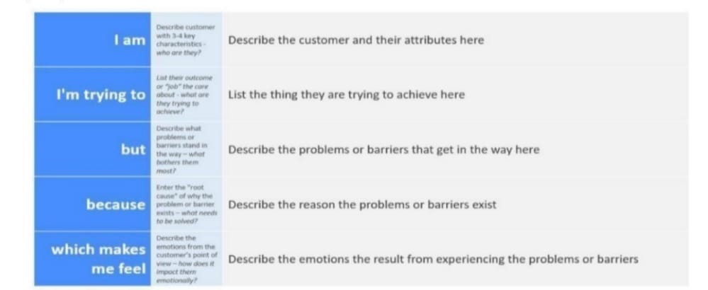

3.IDEATION &PROPOSED SOLUTION

3.1.EMPATHY MAP CANVAS

THE VALUE OF EMPATHY MAPS

As your team identifies what they know about the user and places this information on a chart, you gain a more holistic view of your user’s world and the problem or opportunity space.By having a more holistic view, you gain insights that add layers of context about the relationships between the users and their experiences. A more holistic view can also reveal the ways in whichyour user most naturally engages with what your team designs and builds. In other words, your designs should reach out to the user. Empathy maps can help you do that.

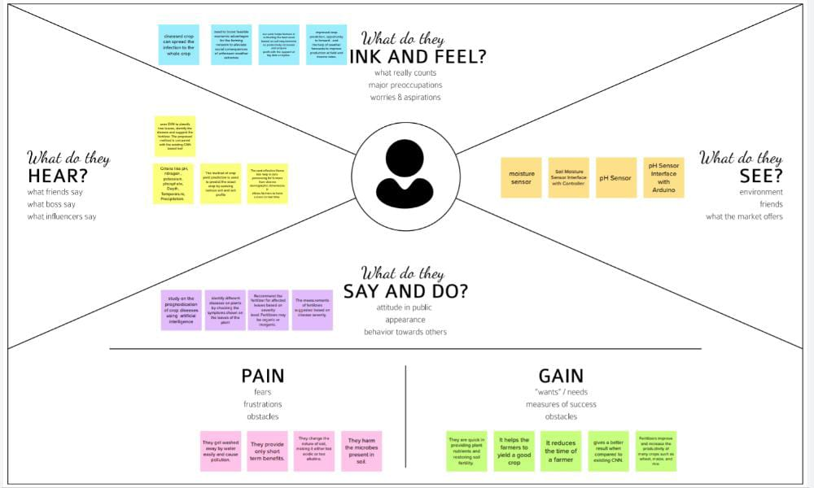

3.2. IDEATION & BRAINSTORMING

Brainstorming is the most frequently practised form of ideation. We recommend that you use it along with Brainwriting, Brainwalking, and Brain Dumping. Here, you’ll learn the best practices from the very best experts from d-school and IDEO as well of the father of the Brainstorming technique, Alex Osborn. Brainstorming is a great way to generate a lot of ideas that you would not be able to generate by just sitting down with a pen and paper. The intention of brainstorming is to leverage the collective thinking of the group, by engaging with each other, listening, and building on other ideas. Conducting a brainstorm also creates a distinct segment of time when you intentionally turn up the generative part of your brain and turn down the evaluative part. You can use brainstorming throughout any design or work process, of course, to generate ideas for design solutions, but also any time you are trying to generate ideas, such as planning where to do empathy work, or thinking about product and services related to your project.

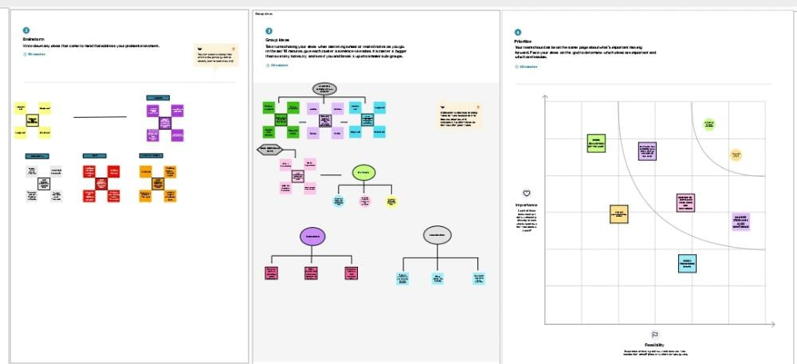

3.Proposed Solution

An automated system that takes the images of plant parts as input identifies different diseases on plants by checking the symptoms shown on the leaves of the plant is built . Deep learning techniques are used to identify the diseases and suggest the fertilizes that can help cure the disease. The user need not consult any specialist for identification of diseases that affected the leaves or for the recommendation of the fertilizers.

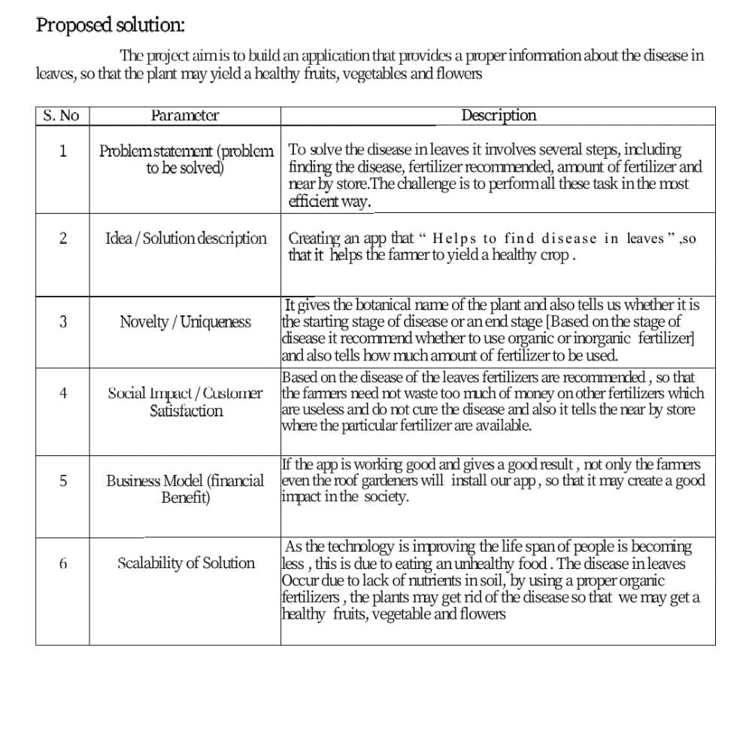

3.1 Problem Solution fit:

The Problem-Solution Fit means that the solution that is realized can actually solve the problem that the customer faces.

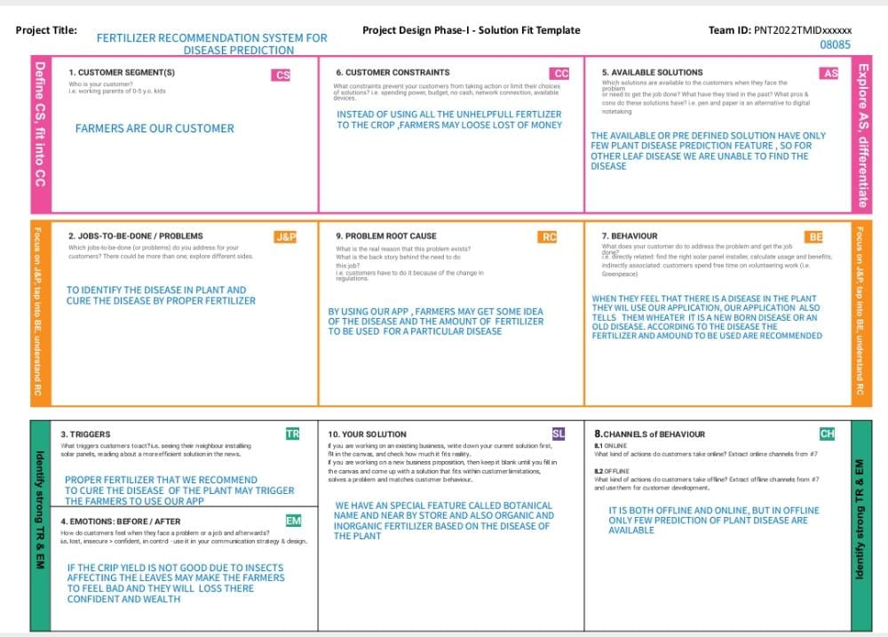

4. Requirement Analysis

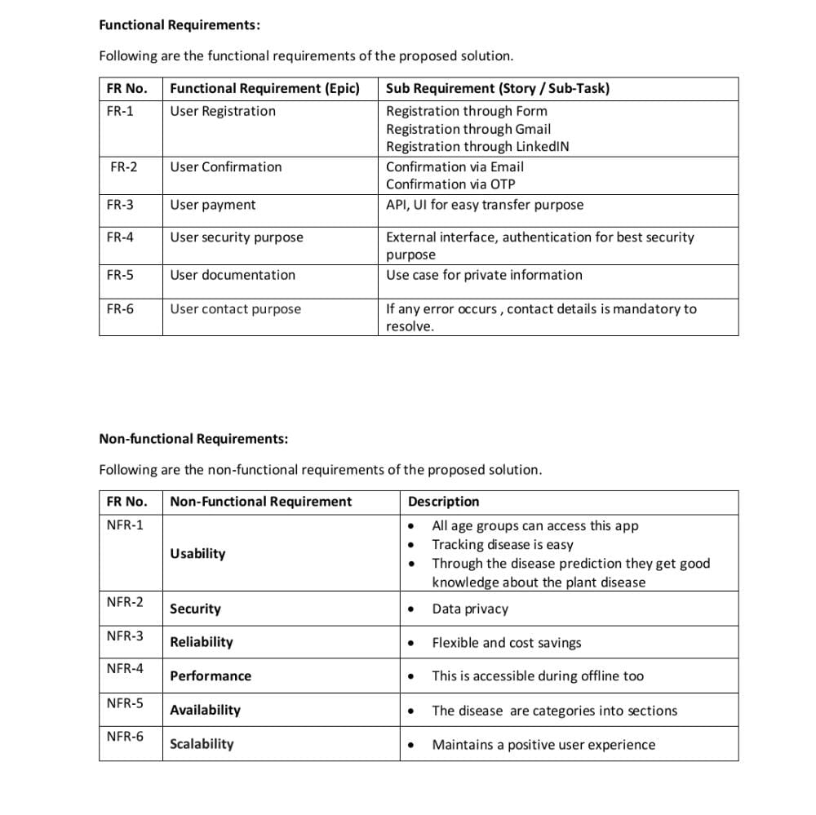

5. PROJECT DESIGN

5.1 Data Flow Diagrams

A data flow diagram or DFD(s) maps out the flow of information for any process or system. DFDs help you better understand process or system operation to discover potential problems, improve efficiency, and develop better processes.

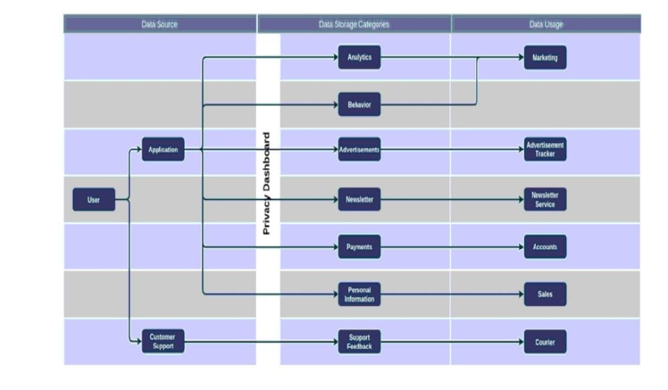

5.2 Solution & Technical Architecture Solution Architecture:

Solution architecture is the process of developing solutions based on predefined processes, guidelines and best practices with the objective that the developed solution fits within the enterprise architecture in terms of information architecture, system portfolios, integration requirements, etc.

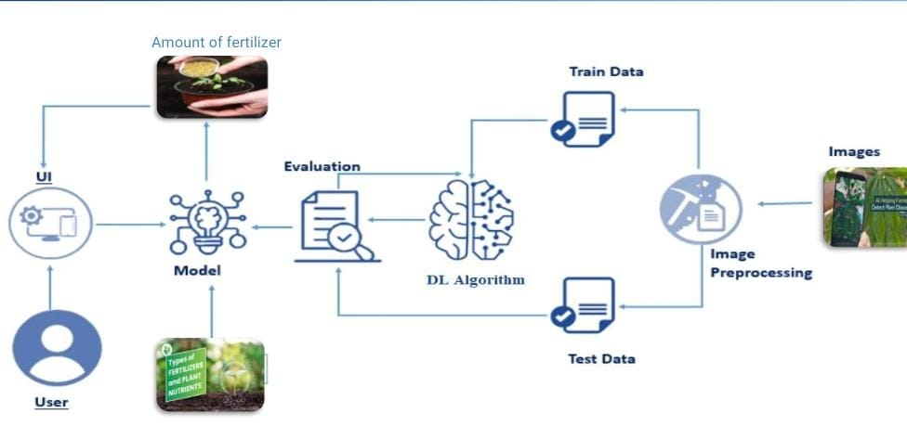

Technical architecture involves the development of a technical blueprint regarding the arrangement, interaction, and interdependence of all elements so that system-relevant requirements are met.

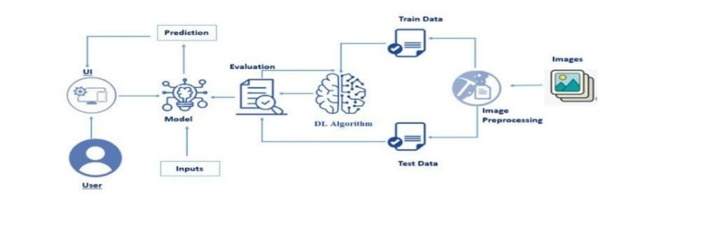

5.3 User Stories

An informal, generic explanation of a software feature written from the viewpoint of the end user is known as a user story. Its objective is to explain how a software feature will benefit the user.

6. Project Planning and Scheduling

6.1 Sprint Planning & Estimation

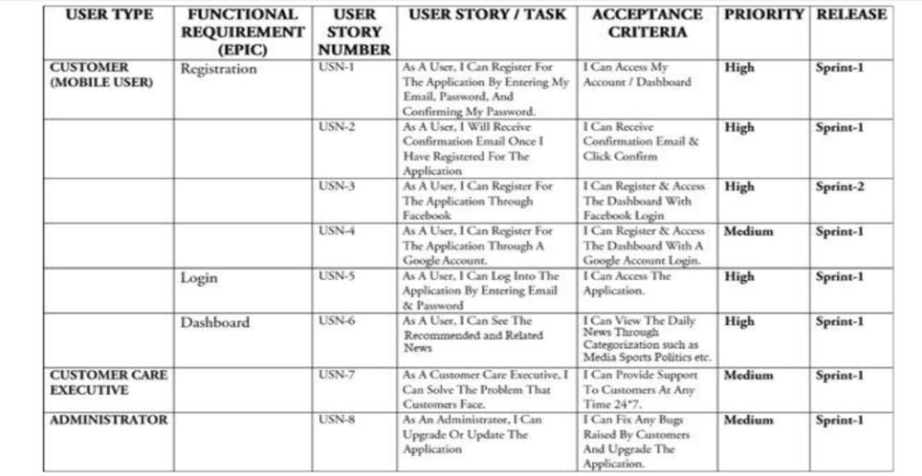

6.2 Sprint Delivery Schedule

Agile sprints typically last from one week to one month. The goal of sprints is to put pressure on teams to innovate and deliver more quickly, hence the shorter the sprint, the better.

<https://github.com/IBM-EPBL/IBM-Project-17828-1659676581/tree/main/TEAM%20PNT2022TMID08085/PROJECT%20DEVELOPMENT%20PHASE>

7 Coding and Solutioning Python –

app.py:

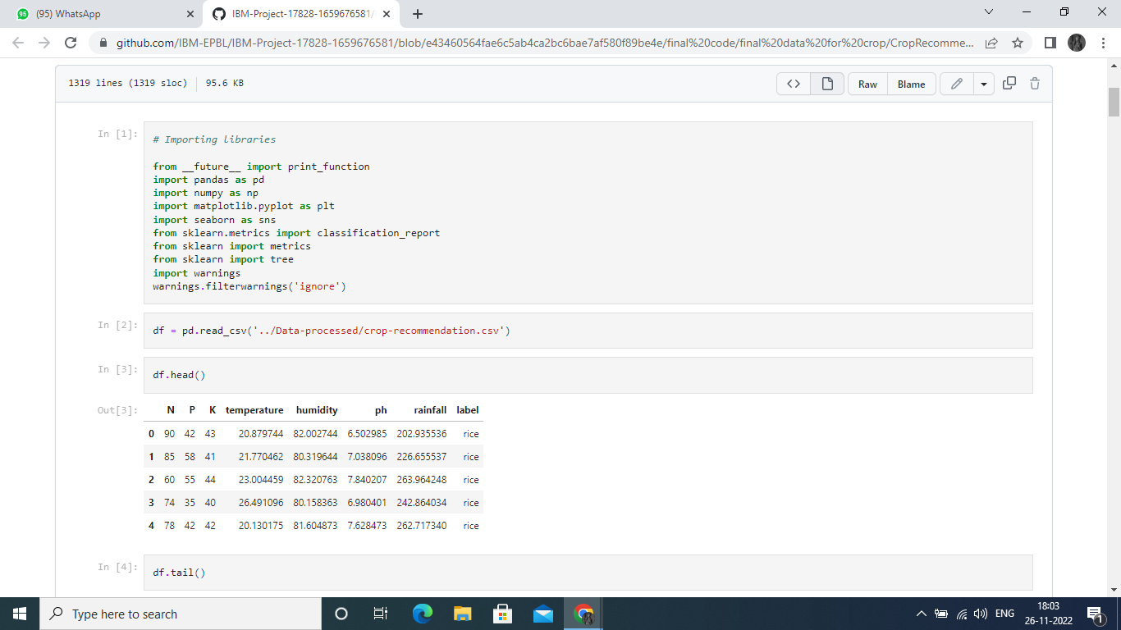

<https://github.com/IBM-EPBL/IBM-Project-17828-1659676581/blob/e43460564fae6c5ab4ca2bc6bae7af580f89be4e/final%20code/final%20data%20for%20crop/CropRecommendationModel.ipynb>

**8. Testing**

**8.1 Test Cases**

Test cases are a set of actions performed on a system to determine if it satisfies software requirements and functions correctly as it claimed to perform



**8.2 User Acceptance Testing**

Before deploying the software application to a production environment the end user or client performs a type of testing known as user acceptance testing, or UAT to ensure whether the software functionalities serve the purpose of development.

<https://github.com/IBM-EPBL/IBM-Project-17828-1659676581/tree/main/test%20both%20the%20model>

**9. Results**

**Performance Metrics:**

Metrics are a baseline for performance tests.

Monitoring the correct parameters will help you detect areas that require increased attention and find ways to improve them.

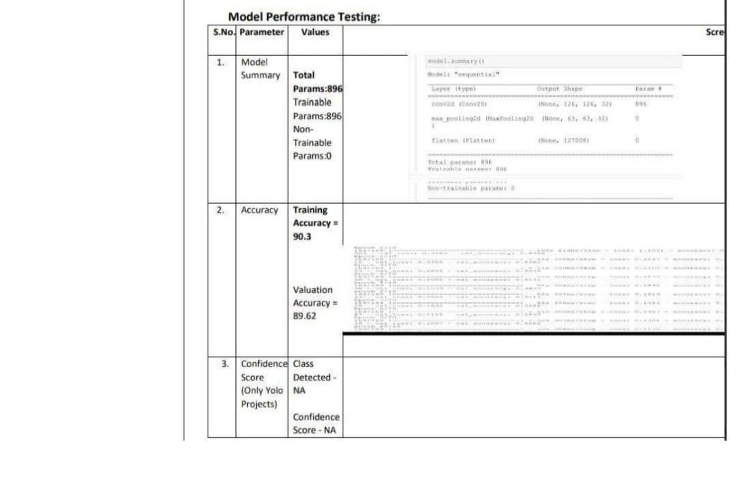

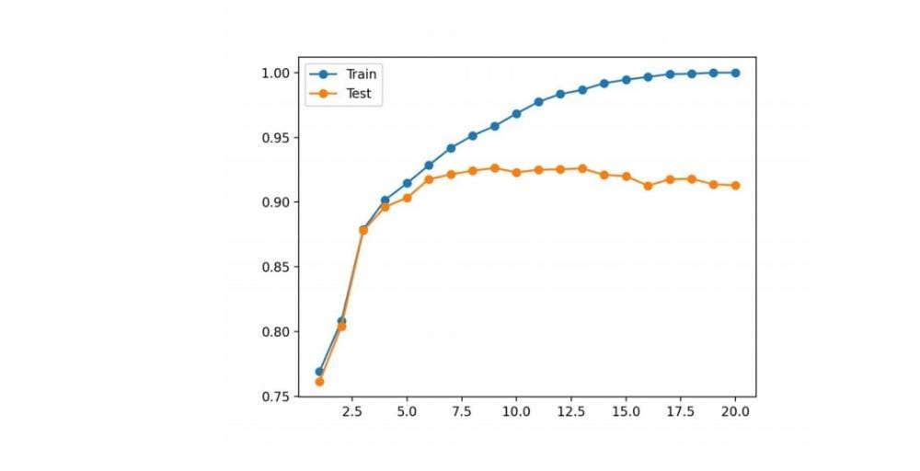

10.Advantages

• Early detection of plant diseases.

• Proper fertilizer recommendation to prevent or cure the plant infection or disease.

• No need to consult any specialists.

• Fully automated system.

11.Disadvantages:

• Requires training the system with large dataset.

• Works only on the pretrained diseases.

• When a plant is infected with multiple diseases the system may not predict all the diseases due to the mixed symptoms.

• Requires a good device connected to the internet.

12. Conclusion:

Hence a system that takes in images as user input, analyses those for certain symptoms and identifies the disease, recommends the fertilizer to counter the deficiency of the nutrients is built and deployed.

13. Future Scope:

The system must be trained with numerous images of plant disease symptoms. In case of presence of multiple 50 50 diseases, suitable classification must be done to predict each disease accurately and recommend separate fertilizers as a solution to each deficiency or infection.

15. Appendix

Source Code



<https://github.com/IBM-EPBL/IBM-Project-17828-1659676581/blob/e43460564fae6c5ab4ca2bc6bae7af580f89be4e/final%20code/final%20data%20for%20crop/CropRecommendationModel.ipynb>